project title:
SMART ECO SYSTEM
TEAM:
Declan Bell, Dorota Marczak, Scott Alan, Nader Sobhi
Outline Business Case & project plan
Version Number: 1.0
Version Date: 20.09.2018

DDNS Ltd., an information technology company located at Abertay University, DD1 1HG Dundee, is pleased to provide this IT Project Proposal to Gavin Hales, the CEO of Abertay Plant System with the headquarter in Dundee.
By the signature of DDNS Ltd. authorized representative hereunder, this IT Project proposal constitutes a formal offer to provide the deliverables described herein on the terms and conditions described herein.
VERSION HISTORY

Version  Number | Implemented  By | Revision  Date | Approved  By | Approval  Date | Description of  Change
1.0 | Dorota Marczak | 09/20/18 |  |  | The executive summary
1.1
1.2

TABLE OF CONTENTS
1 Executive Summary 5
2 Introduction [from here you will be mainly looking at steps 1-3 from the stepwise planning approach discussed in the lecture; answering the questions discussed for each step will help with filling in sections 2-6 of the Proposal Template.] 6
2.1 Purpose of this Document 6
3 gENERAL Project iNFORMATION 6
3.1 Project Description 6
4 High-level Business Impact 7
5 aLTERNATIVES and aNALYSIs 8
6 Preferred Solution 8
6.1 Preliminary Work Breakdown Structure 8
6.2 Assumptions and Constraints 9
7 Detailed PROJECT PLAN [Here you will be mainly looking at steps 4 and ownards from the stepwise planning approach] 9
7.1 Product Breakdown Structure (a visual aid) 9
7.2 Activity Plan (a visual aid) 9
7.3 Resource Allocation and Timeline 9
7.4 Identification of Critical Path 9
7.5 Identification of Costs and Benefits 10
7.6 Justification of Project Approach & Project Methodology 10
7.7 Version Control and Requirements Changes 10
7.8 Quality Assurance and Test Plan 10
7.9 Risk Management Plan 10
8 References 11
Appendix A: Approval 12
Appendix B: Key Terms 14
Appendix C: Team Rules and Roles 15
Appendix D: Minutes & Reflection 16
Appendix E: Peer Assessment 17
Appendix F: Artefact or prototype material 18

Executive Summary
Gavin Hales identified the need for a Smart Eco System for the Abertay Plant System and is looking for a professional IT firm designing & implementing Smart Technologies to perform the following:
- Create an effective & low-cost IoT solution that would monitor the conditions plants are growing in & notify the user about any significant changes
- Control the system remotely through the user-friendly application
- Create reminder of required actions
- Produce data & prepare clear statistics regarding the conditions in the local ecosystem, that will help in optimizing the plant’s growth
- Provide support in the maintenance of the system; both hardware and software
Aim of the Project
The client defined the optimisation of the small plants’ growth as the main goal of the project. The above-mentioned aim will be achieved by combining the vegetation and plantation knowledge of experienced members of the client’s company with the cutting-edge system delivering the necessary data and transforming them into intuitive charts. The final product is expected to perform measurements and record environmental factors (temperature, light level, humidity & soil moisture level), which then will be stored in a special database.
Also, the client wishes to get the access to the data in the form of statistics and notifications through the application designed to control Smart Eco System. From the moment of accomplishing the implementation process, the support on the maintenance will be provided and product tests will be executed on a regular basis.
Development process – Methodology
The development process will begin with the team getting acquainted with the requirements provided by the customer, what then will be followed by the consultations, which will help to clarify the mental model of the future product. The project will be developed in regular collaboration with the client, as this is a critical part of the chosen development methodology. Also, the workflow will be easy to control via an online application providing flexibility of team work.
When the prototype is ready, the proper tests will take place and the feedback from the Project Owner will be requested. At the end, one of the team members will be in charge of preparing a short report including client’s recommendations/requests, as well as any obstacles that were faced and extra notes. The above process will be repeated until a final release.
Potential risks and backup plan
One of the most probable risk related to the project is delay in releasing a fully-functioning product. However, above risk will be minimalised by a rigid work organization and task decomposition. Another issue that may appear during the process is exceeding the budget. This risk, in turn, may be reduced by keeping track of all the necessary hardware and software components. Last but not least, the customer may change his mind and vastly redefine the requirements. To mitigate the above problem we will keep in constant communication with the client, when possible, as this will be a great way to make sure we are on the right track.
Performance indicators & success defining

Mapping key performance indicators onto business objectives

Benefits of selecting our company for the project include:
- Talented team of IT specialists with impeccable references
- Deep domain knowledge & expertise in Smart Technologies
- Cost-effective IT solutions, that will satisfy the customer and fulfil his needs
- Client collaboration throughout the design, development & implementation process, based on regular consultations and prototype testing.
- Track record of client workflow and efficiencies
About DDNS
DDNS Ltd. is a leading provider of expert Smart Technologies to local businesses in Scotland. The company boasts to have served an ever-growing number of clients relying on our experience in the IT field and time-efficient work organization, which gives the ability to complete projects on time and within the customer’s budget.
Contact details:
- Dorota Marczak
Role: Project Manager & Application Developer
Telephone number: 01234567899
Email: email@email.com
- Nader Sobhi
Role: Application Developer
Telephone number: 01234567899
Email: email@email.com
- Scott Allan
Role: Application Developer
Telephone number: 01234567899
Email: email@email.com
- Declan Bell
Role: Application Developer
Telephone number: 01234567899
Email: email@email.com

The executive summary is meant to ‘hook’ your client into the project – why should they consider you etc. Thus, the information you provide should be concise, easy to understand, and catch the client’s attention. It should also be ‘positive’ and reflect that you are full of confidence to be able to do the work, while also showing that you have an awareness of risks and how you tackle them. The reader has to get the impression that your proposal is well planned and feasible to implement.
Provide a synopsis of the key points of this document by outlining for the reader:
- what the project is about (i.e. the brief)
- who the client is (brief outline) and for which organization they are acting
- what benefits your project will provide for the client (not for you)
- how the project aligns with the goals and business objectives of the client organization
- how you will do the project (the most important steps of the methodology)
- what your key performance indicators are for the success of the project and how you would measure your project’s success (e.g. satisfaction/usability scores, percentage of systems that can be hacked into, percentage of tools that flagged up vulnerabilities, response times of developed systems, etc.)
- how your key performance indicators map onto business objectives
- what the major project risks are and how you deal with them
- your contact information

Avoid ambiguous acronyms, overly complicated terminology, etc.

Note that the executive summary repeats what you are writing in the main proposal. However, often clients will only read the executive summary – if this is not useful to them they may often not bother to read the entire proposal. Thus, the executive summary needs to be informative and also capture the client’s interest.

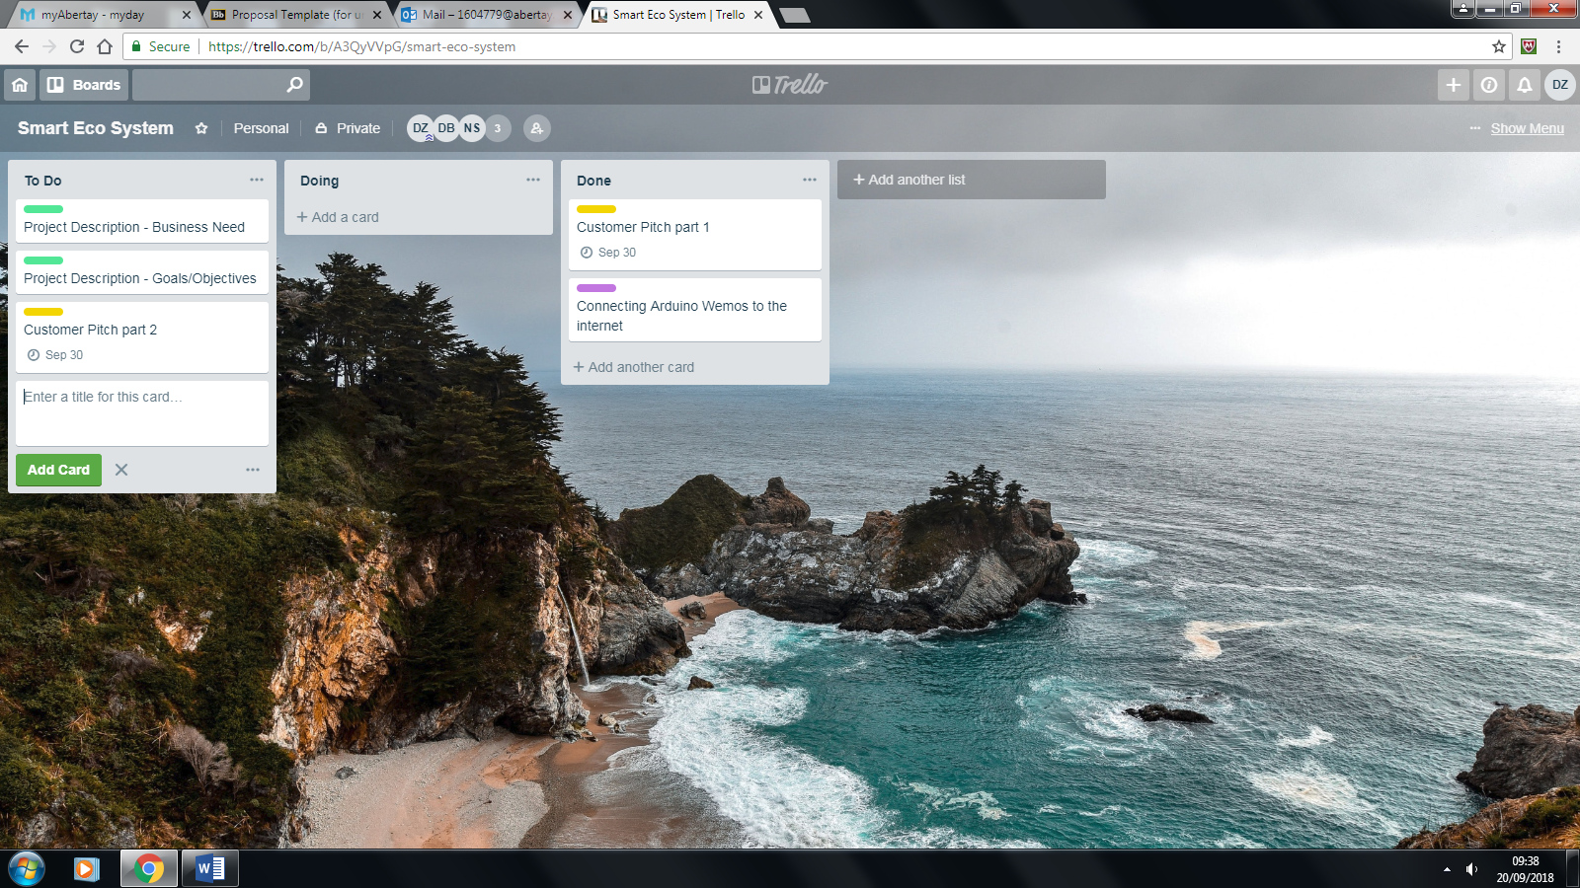

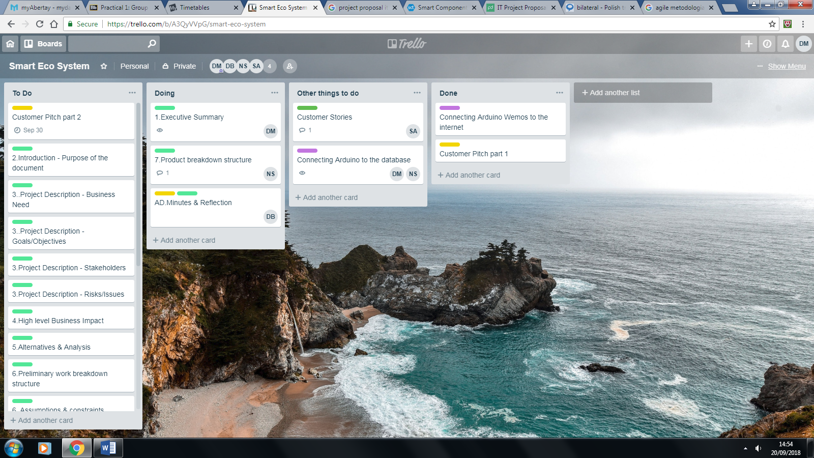

Introduction [from here you will be mainly looking at steps 1-3 from the stepwise planning approach discussed in the lecture; answering the questions discussed for each step will help with filling in sections 2-6 of the Proposal Template.]

Purpose of this Document
[The intended audience this document is project stakeholders such as the Business Owner and senior leadership.

The document assists organizational stakeholders in making decisions regarding the viability of a proposed project effort.

Provide here a short description of the purpose of this document. E.g., “The purpose of this document is to provide the justification for undertaking this project for <client, company name>, based on estimated costs, benefits and risks etc.”

Describe how the viability of the project is monitored and by whom in your team. Note: it is important here to demonstrate that you are responsible for monitoring the viability of the project and that you can evidence how you do this.]

gENERAL Project iNFORMATION
Submission Date | 29 November 2016 [or before it you submit this document before this date]
Requested By | <Enter full name of Client>
Business Owner | <Enter Business Owner/Manager supporting this document>
Contact Info. | <Enter email address and phone number of primary contact>
Project Name | <Enter a name for the proposed project>
Desired Start Date | 9 January 2018
Desired End Date | 18 April 2018

Project Description

Business Need
[Identify the client here – who are they, what type of organization do they work for, what is their main business, why did they want the project, etc.
Enter a detailed explanation of the business need/issue/problem that the requested project will address (business objective(s)).
Include regulations etc., for example, standards you and/or the client have to follow (e.g. ISO, legal, confidentiality issues, laws, acts etc.).
Include any expected benefits from the investment of organizational resources into the project for the client, i.e., not yourself. These should be generic but convincing (e.g. enhanced reputation, savings, secure systems etc.). NOTE: you will talk about the detailed costs and benefits in 7.5.
Describe how your team is related to the client (are you in the same organization as the client or outside the organization) - who are you? e.g., a student group at Abertay; what is your project team organization – how do you fit into this project? Who is ‘boss’, liaising with the client etc ].

Goals/Objectives
[Enter a description of the expected short-term, long-term, and operational goals and objectives of your project.]
Enter a detailed explanation of how your proposed project aligns with, or advances, organizational goals and objectives, and avoids duplication of any enterprise architecture components. Here you are trying to reflect on the higher order organizational objectives and make them part of your plan and project objectives.]

Stakeholders
[Identify the entities, components, and people that have an interest or influence on the project or will be impacted by its outcome, e.g. clients, people using what you develop, your team etc. Identify ‘who is boss’ in your team, and who you are mainly communicating with on the client side. In many cases this will be your subject specialist.
Briefly outline how you keep in contact with the relevant stakeholders (e.g. you may have regular meetings scheduled in your proposal), and communicate and disseminate information.]

Risks/Issues
[Discuss the main risk areas for your project. NOTE: There is a whole section dedicated to risks further below in your detailed plan (7.9). Here you outline relevant risk areas (e.g., staff, technology processes or organization) and briefly how you address them. ]

High-level Business Impact
[Outline what business functions/processes may be impacted, and how, by the project for it to be successfully implemented.
Describe plans for addressing ongoing operations, future growth, and how this will be addressed and managed.
Consider the requirements for additional hardware, software, building materials, resource requirements, staffing, training, other expenditures, etc.
Describe how the performance of your project will be measured, and identify associated key performance indicators; describe how these address a particular business objective and/or need. Note: You will provide more detail on this in 7.8]

aLTERNATIVES and aNALYSIs
[The Alternative Analysis section should identify options and alternatives to the proposed project and the strategy used to identify and define them.
Do some research on the Internet/library systems – what other systems are out there? You need to reference what you discuss (there is a reference section at the end of the document).
Further analysis of these potential options should be performed to identify a preferred solution.
Include a description of the approaches for the identification of alternatives and an outline/description of each alternative considered. Include at least one viable alternative: e.g., keeping things “as-is” or reuse existing people, equipment, or processes; identify one as the preferred solution.
Some examples of alternatives to consider may include:
- Buy vs. build vs. lease vs. reuse of existing system
- Outsource vs. in-house development
- Commercial off the shelf (COTS) vs. Government off the shelf (GOTS)
- Mainframe vs. server-based vs. clustering
- Unix vs. Linux vs. Windows etc.

Clearly indicate your preferred solution – naturally, in this case, this has to be your project. ]

Preferred Solution

Preliminary Work Breakdown Structure
[Include a Work Breakdown Structure (WBS) for the preferred solution. The preliminary WBS organizes and defines 100% of the scope of project work to be accomplished and displays it in a way that relates work elements to each other and to the project’s goals. Consider what activities (e.g. requirements analysis, design, coding, scripting, performance tests, investigations, … ) you need to carry out to meet your proposed project objectives, (e.g. develop a honey pot, break into a network system, design a website, app etc.)

You may want to search the Internet for information on WBS, for example,
https://www.projectsmart.co.uk/work-breakdown-structure-101.php
https://www.workbreakdownstructure.com/

Also indicate briefly which methodology / approach you have chosen for your project, e.g. Waterfall, Incremental, Prototypes, Spiral, Agile etc. You talk more about this in section 7.6.]

Assumptions and Constraints
[An assumption is a guess as to what you can take as a given in your project, e.g., access to labs, availability of equipment etc. A constraint may be a limitation in relation to the project, e.g. no 24 hour access to labs etc.
Include a detailed explanation of any assumptions and constraints applied to the information within this document. You can consider factors such as, e.g., market demand for this product, tool etc., support available, something you need from the client, lab access etc. ]

Detailed PROJECT PLAN [Here you will be mainly looking at steps 4 and ownards from the stepwise planning approach]

Product Breakdown Structure (a visual aid)
[Indicate what products you want to deliver in a breakdown structure diagram. In addition to code/website/tool/documentation on exploits/vulnerabilities/tutorials etc. this will also include the white paper at the end of CMP311 (the follow-up module), as it is a document you hand over to the client. Note that you have about 12 weeks to actually work on the product in Term 2 for CMP311. Describe the main products.]

Activity Plan (a visual aid)
[Insert an activity plan diagram. What are your activities? Think about the order in which you need to conduct activities. Describe the main components.]

Resource Allocation and Timeline
[Insert a resource plan (some visualization, e.g. Gantt chart).]

Identification of Critical Path
[Insert an activity / Precedence network diagram to identify the critical path in your project. Describe the critical path briefly.]

Identification of Costs and Benefits
[Describe costs and benefits for the client.
Remember: Costs and benefits may not necessarily be monetary, but can be. You can make costs up if you like if you want to charge the client (this obviously will not happen in your project). ]

Justification of Project Approach & Project Methodology
[Discuss why your chosen project approach (SCRUM, waterfall, spiral etc.) is appropriate for your project and why other approaches are not appropriate. Your argumentation should make reference to project features (e.g. available time, difficulty of the project, complexity and uncertainty, for example.]

Version Control and Requirements Changes
[Discuss how you would deal with version changes and communication of those within the team and relevant stakeholders.]

Quality Assurance and Test Plan
[Discuss how you would test the quality of your project. Consider, for example, ISO standards, usability or legal issues, etc. You need to identify how you make sure your project is up to the required standard. Consider also what variables are you collecting to make sure you can objectively say your project is successful (e.g., number/percentage of exploits detected – what would be an optimum number/percentage compared to a known baseline? Or a survey score – what would you want to achieve in terms of usability if you designed a website and what standards do you have to follow? Or how do you make sure your code is reasonably error free, your product ‘behaves’ as it is meant to behave etc.) ]

Risk Management Plan
[Discuss your identified risks in detail. These might be, for example: Staff, Schedule, Initial Costs, Life-cycle Costs, Technical Obsolescence, Feasibility, Reliability of Systems, Dependencies/Interoperability, Surety Considerations, Future Procurements, Project Management, Overall Project Failure, Organizational/Change Management, Business, Data/Information, Technology, Strategic, Security, Privacy, Project Resources.]

Discuss how you would deal with the identified risks; use some sort of visualization, e.g., a risk matrix etc. to illustrate the most sever risk you need to monitor.]

References
[Insert your references here. References may arise from section 5, for example, when you research alternative solutions for the project brief.
Use a consistent format, e.g. Harvard (or whatever the University is using) - http://www.citethisforme.com/harvard-referencing, but any format is fine as long as you use it consistently for your references. ]

Appendix A: Approval
The undersigned acknowledge that they have reviewed the <Project Name> Project Proposal and agree with the information presented within this document. Changes to this document will be coordinated with, and approved by, the undersigned, or their designated representatives.
[List the individuals whose signatures are desired. Here, team members, clients etc. should be listed. Add additional lines for signatures as necessary. This form should be signed and scanned into the document. NOTE: You need to get a real signature from the client, so make sure you get this in due course so you can submit the proposal.]

Signature Team Member: |  | Date:
Print Name:
Role:

Signature Team Member: |  | Date:
Print Name:
Title:
Role:

Signature Team Member: |  | Date:
Print Name:
Title:
Role:

Signature Team Member: |  | Date:
Print Name:
Title:
Role:

Signature Team Member: |  | Date:
Print Name:
Title:
Role:

Signature Client: |  | Date:
Print Name:
Title:
Role:

Appendix B: Key Terms

The following table provides definitions and explanations for terms and acronyms relevant to the content presented within this document.
Term | Definition
[Insert Term] | <Provide definition of term and acronyms used in this document.>

Appendix C: Team Rules and Roles

[List what your team rules are – for example, how do you deal with absences, disagreements; do you have a democratic decision making process etc.

List what your individual team members’ roles are, e.g. keeper of minutes, developer, manager, designer, coder etc.]

Appendix D: Minutes & Reflection

[This section should contain detailed minutes of meetings.
This should comprise:
- Date, time and venue of the meeting
- Who is present
- Any absences and apologies received
- Approval or amendments of previous minutes if available (review)
- A description of what is discussed and agreed upon (or not) in the current meeting
- Any challenges flagged up (in the team) and how were they addressed
- Actions for next meeting
- Date, time and venue for next meeting

There should also be a brief section on the atmosphere/challenges within the team, how team dynamics were addressed etc.
]

Appendix E: Peer Assessment

Name (print) for each team member (including yourself) | Each team member should individually and confidentially upload this form to BlackBoard, using the ‘Peer Assessment’ link in Blackboard (via ‘Submit Module Assessment and Deliverables under Assessment information). Each team member should select a mark from 0, 0.5, 1, 1.5, 2, 2.5, 3, 3.5, 4, 4.5 to indicate how well they think the other team members have contributed to the TEAM WORK (you also give a mark for your own contribution to the project to yourself).

Appendix F: Artefact or prototype material

[This section can contain preliminary work, e.g. website pages prototypes, code, a selection of tools, images of displays etc.
]

